SOA LOAD BUTTON ISSUE

**CASE 1:**

1. Open the Order in QSOTS
2. Check for ICORE LOAD DATES
3. If the order is loaded to ICORE or there is error in ICORE load date column and SOTS LOAD Button is missing

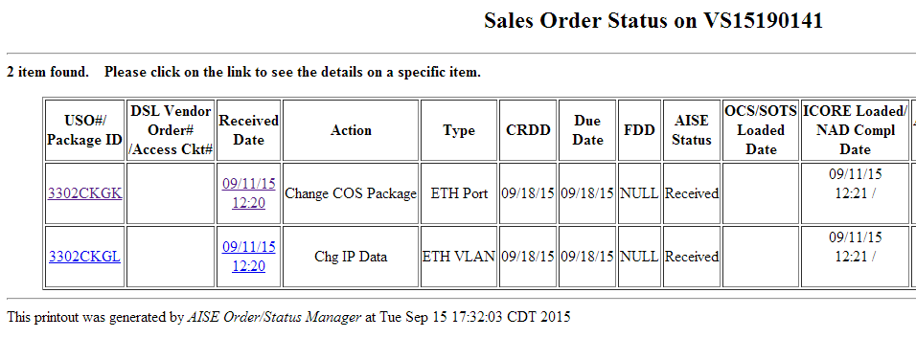

1. Then check, how the order is loaded to ICORE

* You need to check special_handling_type in activity_plus table
* select special_handling_type from activity_plus where activity_id =xxxxxx

|  |  |
| --- | --- |
| Value | Meaning |
| 0 | RPC |
| Null | RPC |
| 2 | WS |
| 3 | CSI |

1. Then check for error in PA(Port Assignment) logs:

{These are ICORE response to USRP}

* For RPC:

cd /opt/frame/log

grep –l “Sales_order_numer” *icore_rpc*

* For WS/CSI:

cd /opt/frame/log/waslog/wsserver/icore/portassignment

grep –l “Sales_order_numer” *

**CASE 2:**

1. If the Order is not loaded in ICORE and SOTS
2. Then firstly check for activity_plus.special_handling_type
3. Then accordingly check the Request Logs (Request that is being sent from USRP to ICORE)
   * For RPC:

cd /opt/frame/log

grep –l “Sales_order_numer” *icore_rpc*

* + For WS/CSI:

cd /opt/frame/log/waslog/wsclient/icore/multivlanservice

grep –l “Sales_order_numer” *

**CASE 3:**

* + If some of the uso’s are loaded to ICORE and SOTS but few of them are not, then check for candidate types first.
  + Select ocs_candidate_type,sots_candidate_type,icore_candidate_type from activity_plus where activity_id=xxxxxx
  + For E.g. USO: 38572358 is not a candidate to load ICORE

|  |  |  |  |  |  |  |
| --- | --- | --- | --- | --- | --- | --- |
| Count | sales_order_name | uso_number | activity_id | ocs_candidate_type | sots_candidate_type | icore_candidate_type |
| 1 | VS15078498 | 38572358 | 16362973 | A | D | N |

**How to find activity ID?**

* You can find activity_id in DSOTS

or

* select * from acty_by_so where sales_order_name=”VSxxxxx”

